Ref. 746/SS/MG/cg
Milan, May 19th 2014

Dear Designer,

for the past 9 years SaloneSatellite, event held within I SALONI WORLDWIDE MOSCOW, proved to be a successful initiative and for this reason we are happy to share with you this 10th Russian edition, that promises to be another success. Thanks to the very high standard of the art works presented last year, it has encouraged us to give this opportunity to other talented Russian and Former Soviet Republics’ young designers and graduate-to-be students.

SaloneSatellite Moscow will be held within I SALONI WORLDWIDE-FURNISHING IDEAS MADE IN ITALY, in Moscow at Crocus Expo, building 2, 65-66 km MKAD, Krasnogorsk , Russia, from October 15th to October 18th , 2014 and this year we will be celebrating “10 years” of its foundation. This particular event will offer Russian and Former Soviet Republics’ young designers an excellent opportunity to gain visibility among the Italian furniture industry by presenting designs of products that can eventually be considered for mass production and also to be known by the international press and trade visitors.

Following are the rules to follow in order to:

- Each designer is asked to send 2/3 photographs of their designs (very legible and clear) to be selected by a Committee, afterwhich a prototype must be made on the design selected, to be exposed at SaloneSatellite Moscow.

- Designers participating will be sharing a lounge area furnished with tables and chairs where they can place their computer/laptop to meet with manufacturers, press and trade visitors in order to inform and explain their designs. The prototype and/or design that in the meantime you have prepared will be showcased nearby in a well displayed exhibition within I SALONI WORLDWIDE MOSCOW.

- A panel of furniture-design experts will select the best entries. The awards based on a 1st, 2nd and 3rd prize will grant the Russian and Former Soviet Republics designers a free space/booth to participate to the international SaloneSatellite that will be held within the Salone Internazionale del Mobile ( International Furniture Fair ) in Milan form April 14th to April 19th 2015, in which opportunity you can express your creativity to a wider audience visiting this event. We are happy to inform you that last year winners Maria Ignatova (Russia), Evija Kraukle (Latvia) and Wishnya (Russia) were in Milan at SaloneSatellite in April 2014, obtaining an incredible visibility and great success.

- Participation to this event will be entirely free.

- SaloneSatellite Moscow is open to individual or groups of designers. In no case should the age of the designers be over 35 years old.

If you would like to take part in this project please confirm by returning the enclosed format duly filled out complete with 2 or 3 design photographs to be evaluated by a jury of experts that will confirm the validity of the design. To this purpose, we remind you that your project must refer to products mainly in the home, office and contract furniture field and, of course, not yet in the market. Kindly send the above requested not later than June 30th to SaloneSatellite (cghilardi@cosmit.it).

We are confident that this project will be of your interest and look forward to your early reply.

Yours sincerely,
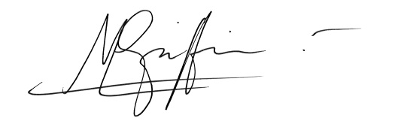
Marva Griffin Wilshire
Curator SaloneSatellite

